User Story:
Description:
As a User,
I want to upload a copy of my current passport
and provide my passport number and expiry date
so that My passport details are saved to the system .

Acceptance Criteria:
BDD Scenario:
Scenario: User uploads the passport in the System
Given I am the (type of )User
When I open the form
And I click on Passport upload button
Then I should able to upload My Passport copy from my device
And I should able to view the uploaded copy of my passport
And I should able to remove the passport copy that I have uploaded
When the size of the uploaded file is greater than 2MB
Then an Error Message “Size of the file should not exceed 2MB”
When the file format is other than the JPEG,PNG,DOC,or PDF
Then the document should not be uploaded an error message should be displayed to the user
When I enter my passport number and expiry date in the Passport Number and Expiry date fields
And click on Save/Submit button
Then My passport details should be saved to the system
And a message “Passport details is saved to the system” should be displayed to the user

Task 3:
Bug Report:
Title: AS BUILT UI Issues
Description:
The below contents in the screen AS Built doesn't match the AS design.
1.Mismatch of words.(ex:
2.Two user names are displaying in the screen
3.Colour code Mismatch in the button
4.Clara academy with (?) is displaying in the footer
5.”What is this?” text alignment and font is not as design.
6.Client count is not displaying at the top
7.(?) is missing at the header next to entity name
Steps to Reproduce:

Expected Result:
1.All the wordings in the AS Built should be same as that of the Design .
2.Only a single and correct user name should be displayed at the top right corner of the design.
3.Colour code in the Buttons should be same in AS Build and Design.
4.Only the Clara logo alone should be displayed in the footer.
5.”What is this? “ text alignment, font and display should be same as that of design
6. “Client, current client/Total no of clients” should be displayed at the top like the design
7.(?) should be displayed at the top right corner next to the entity name

Actual Result:
1.All the wordings in the AS Built doesn’t match the Design .
2 Two user names are displaying in the screen
3.Colour code in the Buttons doesn’t match the Design.
4. Clara academy with (?) is displaying in the footer along with the Clara logo.
5.”What is this? “ text alignment, font and display doesn’t match the design
6. “Client, current client/Total no of clients” isn’t displaying at the top .
7.(?) isn’t displayed at the top right corner next to the entity name

Screenshot:
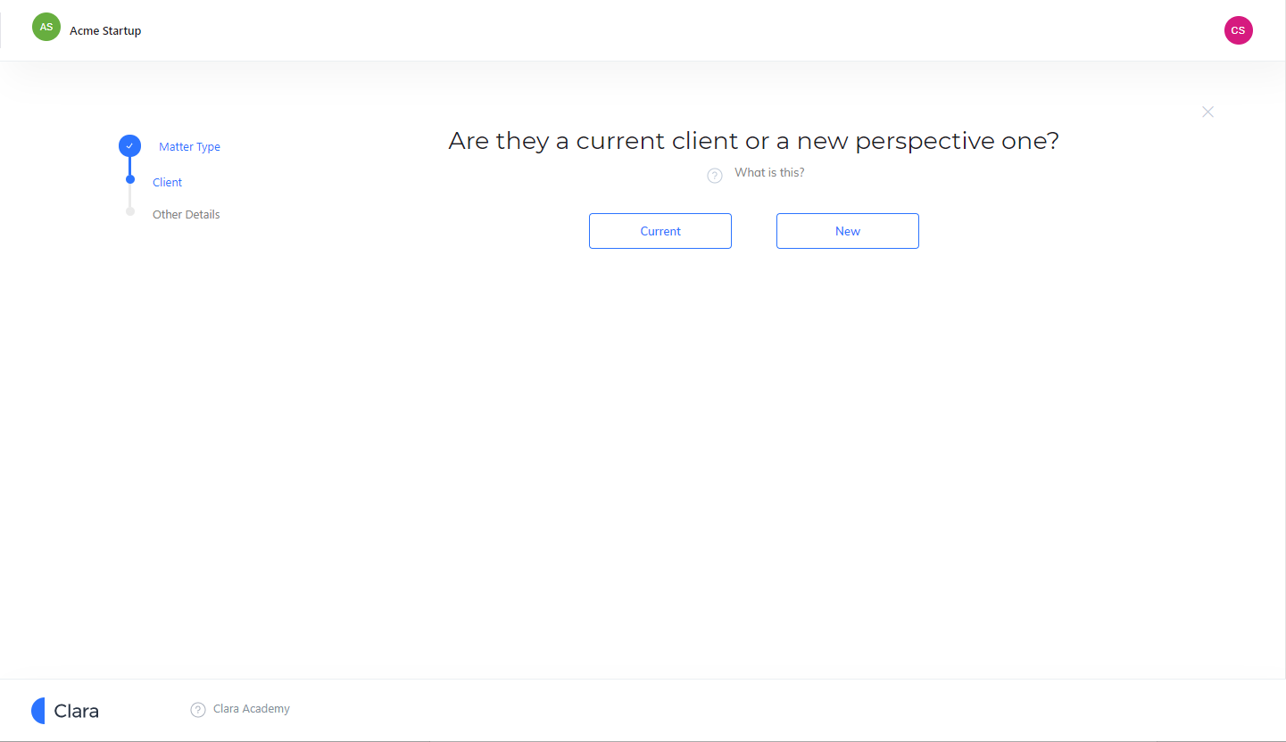
2
2
3
4
5
6 → Client, current client/Total no of clients
7

TASK 5:Bug Report:
Title: Clara | Login issues in Test Environment
Description:
Fiona- Founder is having a couple of problems with her login.
Issue 1. she does not have trouble logging in on her desktop at the office browser, but when she uses her laptop browser, she gets the incorrect password issue.
Issue 2. She says that sometimes she can login without any problems but sometimes she clicks on Login, and it takes over a minute to respond.
I try to replicate the same issues in my device using Fiona’s credentials and find below my findings.
Issue 1: Steps to reproduce:
1.Navigate to the https://test.clara.co in the chrome browser
2.Enter the username as fiona@acmestartup.com and PW: 123clara
3.Click on Login
Expected Result:
Clara | Startup’s Legal OS page should be displayed to the user
Actual Result:
Error Message “invalid username or password” is displaying to the user.
401 unauthorised is displaying in the consoles log for the request.

Error Screen:
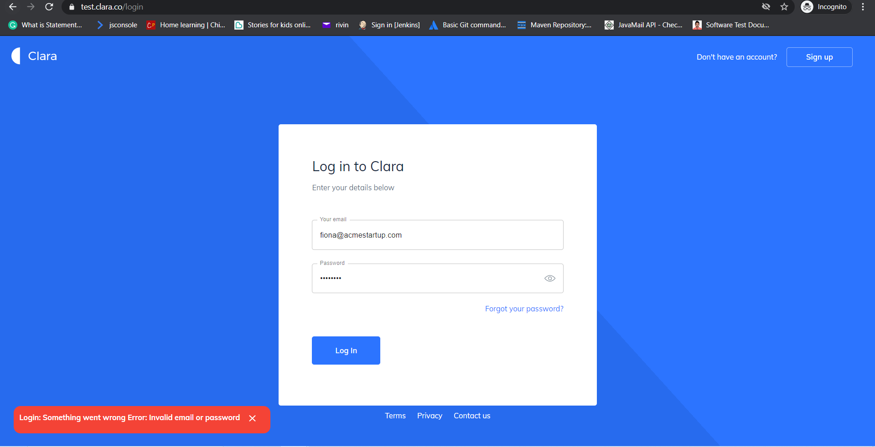
Console output:
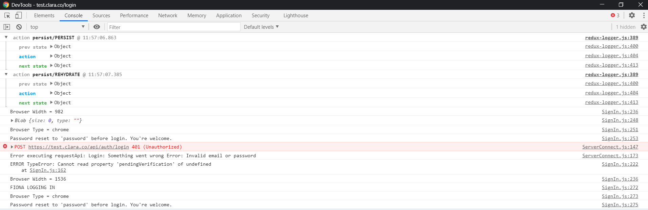
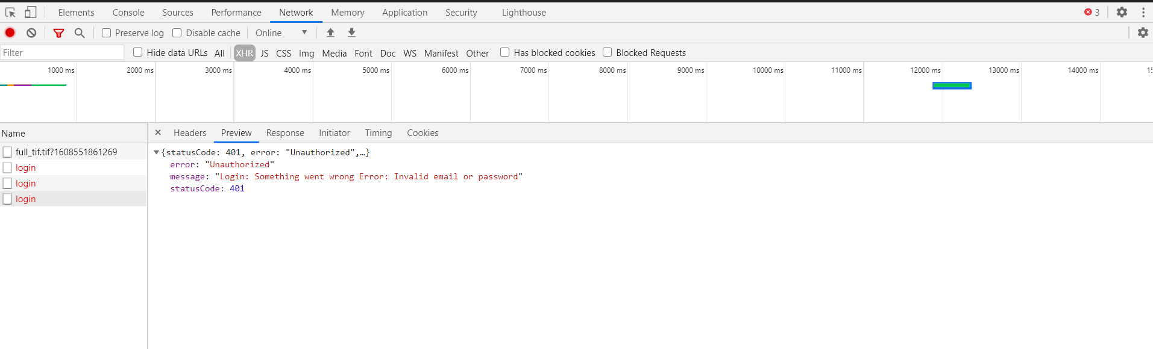

Issue 2: Steps to reproduce:
1.Navigate to the https://test.clara.co in the Edge browser
2.Enter the username as fiona@acmestartup.com and PW: 123clara
3.Click on Login
Expected Result:
Clara | Startup’s Legal OS page should be displayed to the user
Actual Result:
Blank Page is displaying to the user with following error’s in the console log.
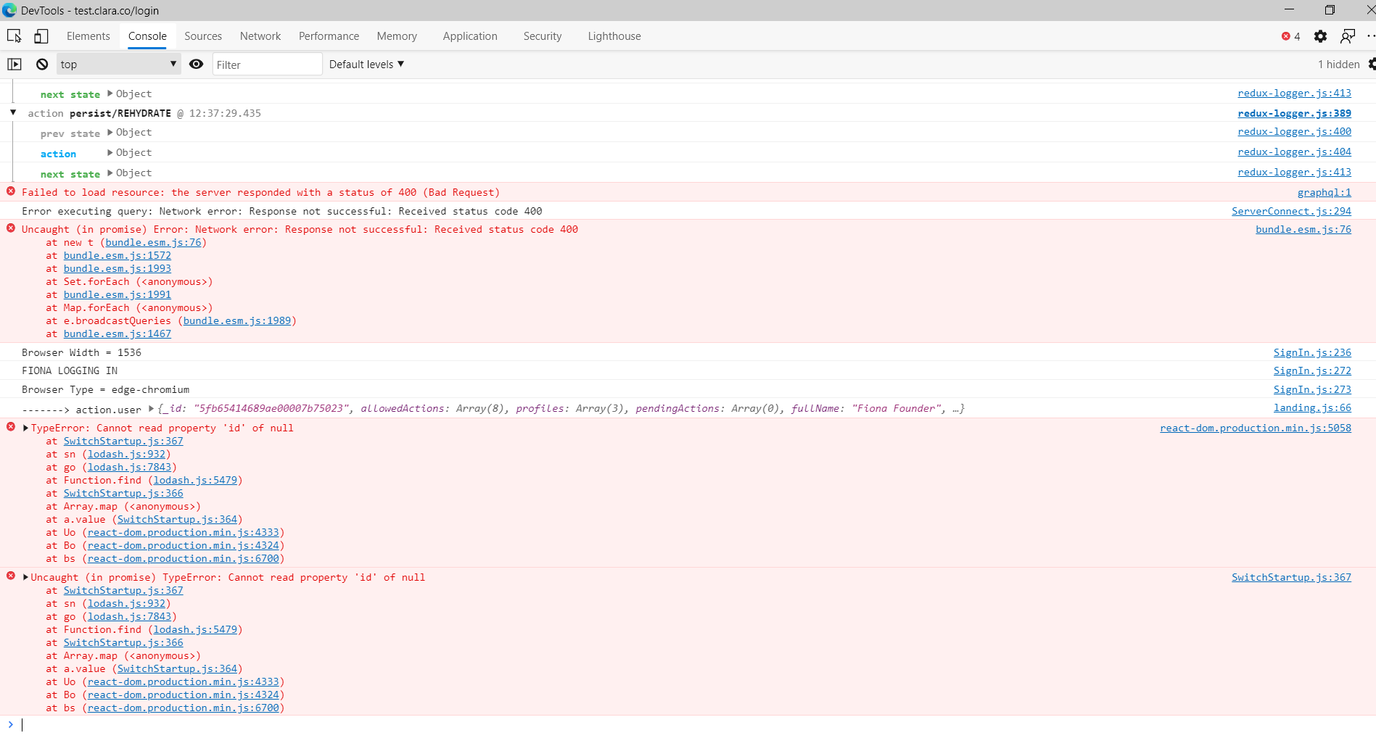
Blank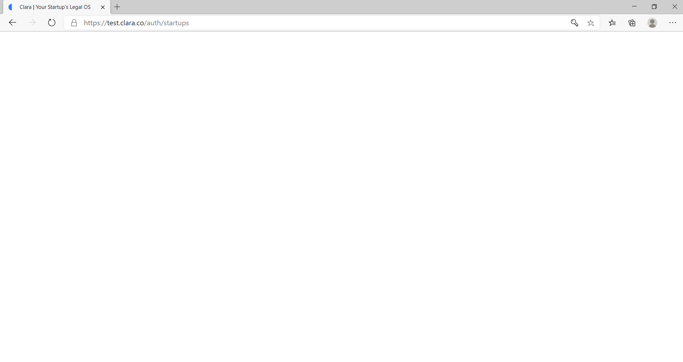

XHR Response and request:
